Fall 2014 Senior Design Proposal

Group 2

Prepared for:

Dr. Latcha

Dr. Gu

By:

Paul Kruchko (EE), Project Manager

Michael Laba (ME), Mechanical Design Team Lead

Bryan Jagielo (EE/CE), Electrical and Controls Team Lead

Xiaoang Tong (EE)

Monika Shaeff (CE)

Ran Ao (ME)

Xinfeng Shi (ME)

September 23, 2014

**Introduction**

Senior Design Group 2 was assigned the task of constructing a machine that could efficiently and accurately count parts needed by an assembly worker and dispense those parts into a worker’s awaiting hand, thereby reducing the chance of parts being dropped on the floor and discarded. This proposed device has the potential for optimizing throughput time in the assembly process while saving money in lost and discarded parts.

**Proposed System**

The system that Group 2 proposes is a closed-loop, feed-back, electronically controlled vibratory bowl feeder that agitates, actuates, and organizes a set of homogenous hardware components that are to be counted and dispensed into the awaiting hands of the operator/user.

The overall structure of the system is a bowl that serves as a hopper and transducer placed at the rear-end of the system. Inside the bowl is a spline that ascends to the top of the bowl and narrows along its path. Meeting the spline at the top of the bowl is a PVC tube and a control gate that is attached to an RC servo motor. Attached to the tube are 6 pairs of diametrically opposing photo electronic sensors, evenly spaced to count parts to be dispensed and measure the velocity of those parts. Waiting at the end of the tube is a staging trough that can dump the counted parts into the dispense funnel or into the reject bin. At the front end of the system is a flat panel that contains the user interface (UI) and dispense door. The UI consists of; a red lamp and a green lamp, a 2x16 LCD display, a six position granulated turn knob, a “Start” button, a “Load” button, a “Select” button, a “Up” button, a “Down button” and a NEMA certified emergency stop button. At the bottom of the front panel is a door that the user must push in with his/her hand to receive the requested number of parts.

The overall theory of operation of the system is that the user would deposit no more than 50 parts at a time in the vibratory bowl, which doubles as a hopper. Once the user has deposited the parts to be counted and dispensed into the bowl, the user would initiate the load sequence of the machine by pressing the “Load” button. Then the machine would output on the LCD screen, “Please select a part.” The user would then select the profile of the part using the “Up” and “Down” keys and once the desired part was displayed on the LCD screen the user would then press the “Select” button. The loading sequence would cause the vibratory action of the bowl to begin and agitate the parts in the bottom of the bowl to start to move along the dispense path. During the loading sequence the red lamp is illuminated and the LCD displays, “Loading…”

This vibratory action is produced by periodically energizing a pair of opposing electromagnets in the base of the bowl. The bowl itself would be mounted to a cross member that would have two armatures attached to it that would be pulled towards the electromagnets when energized. The motion due to magnetic forces would then be complimented by a pair of leaf springs that would snap the bowl back into its original position on the de-energized state of the electromagnets. This periodic motion would produce a coupled moment on the bowl that would then be transferred to the parts inside.

The moment produced would cause a mass flow rate of the parts to begin, with the moment turning into a normal and tangential angular acceleration on the individual parts. The tangential acceleration on the masses would produce a force that would cause the individual parts, collectively, to move along a spiral path ascending up the sides of the bowl. The spiral path would then begin to narrow, forcing individual parts more into a single line. A height deflector would then be placed in the path to deflect parts that have vertically stacked on top of each other off of the main path, and back into the bowl. In addition to a height deflector, an agitator stick would be connected to the side of the bowl, with the sole purpose of knocking the longer screws and items into one of two orientations, allowing them to be perfectly lined up with each other length-wise. These length-wise and single-file arrangements would cause the order of the parts to be more conducive to counting by way of the photo-electronic sensors.

Once the parts have been ordered into a single file line they are forced into a channel at the top of the bowl and at the end of the path, the width of which is manually adjusted by a block plunger system that is fixed in between two mounting brackets that have holes set at the right width for a given part. At the end of channel are a capacitive proximity sensor and a control gate mounted onto an RC servo motor. The vibratory motion continues to maintain the density of the mass flow to guarantee instantaneous system response. The control gate keeps the agitated parts from moving forward and down into the transfer tube until user input is received.

When the capacitive proxy sensor senses the presence of the first part the red lamp is extinguished and the green lamp is illuminated to indicate that the system is ready to start dispensing parts and the LCD displays, “Please select quantity and press ‘Select’”. At this point the user rotates the number of parts desired from 1 to 6. Once the user has selected the desired quantity of parts to be dispensed by way of the granulated knob he/she would then press the “Select” button initiating the count and dispense sequence. At that time the green lamp would extinguish and the red one illuminate. The LCD would display, “Dispensing parts, please wait…” During the count cycle the control gate swings open and allows the parts to fall into the funnel for the transfer tube. During the descent of the part through the transfer tube the beam of the photo-electronic sensor array is broken as the falling part passes through triggering the corresponding port on the microcontroller. The count is determined by the breaking of any of the beams in the array, while the velocity of the falling part is determined by counting the time of the breaking of the first beam and all of the subsequent beams given the fixed distances between them. The microcontroller calculates the velocity of the part by dividing the distance between the sensors by the mean average time difference that the beams of the sensors were broken. The velocity that is measured and calculated by the microcontroller controls the frequency of the pulsing electromagnets which controls the rate of the mass flow, this way the system is able to automatically adjust its own speed. This guarantees that the system dispenses the parts slow enough for an accurate count, but fast enough for a timely dispense cycle. Each part will have a profile programmed into the microcontroller. This profile includes the velocity that the part should be descending through the transfer tube. This velocity also allows the microcontroller to sense an error condition has occurred if the part selected does not match the velocity profile of the part being dispensed. If this is the case then the microcontroller can reject what has been dispensed already by actuating the staging trough to rotate to the discard direction to discard any contents into the reject bin. This causes the microcontroller to close the control gate, actuate the staging table into the discard mode then re-attempt the count cycle again. If the count cycle fails three times in a row then the system will alert the user by displaying a message on the LCD that reads, ”Catastrophic error, please conduct remedial actions.” If this is the case then then it would be necessary for the user to visually inspect the cause of the error. This would most likely not be the case, but there is error handling designed into the system and an NEMA compliant emergency stop button, that when pressed cuts-off system power so that if any error occurred it could be safely inspected.

Once the successful count cycle has finished the desired quantity of parts would be staged waiting in the staging trough. Once the system senses that the desired quantity of parts have been dispensed and that no error conditions exists, then the trough would be rotated to the dispense side, allowing the parts to fall through the dispense funnel and into the dispense cup. Once the parts are dropped into the dispense cup the system would extinguish the red light and illuminate the green light. A message on the LCD would display, “Please push in dispense door to receive parts…” Once the user pushes in the dispense door a transfer rod causes a pivot arm to push the cup forward by another transfer rod and the cup slides forward over the final dispense funnel. The cup itself is bottomless, with only a plate beneath it when the parts are being dropped in from the staging table. This allows the parts to fall through the bottom of the dispense cup, through the dispense chute, and into the awaiting hand of the user. The door/cup system employs the use of limit switches to determine if the user has fully-actuated the door or not. If the user does not claim the parts the system will wait indefinitely until the user claims the parts. Once the user claims the parts the system is reset and ready to receive another selection or be loaded with a different type of part.

**Diagrams and Sketches**

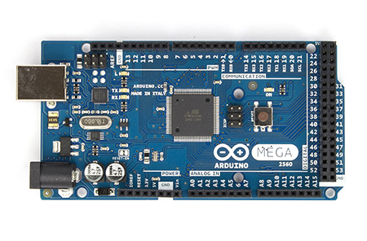

Arduino Mega 2560 R3 Front

**Expected Specifications and Features**

|  |  |
| --- | --- |
| **PRODUCT INFORMATION** | |
| SKU | 194746 |
| Mfr Part# | 194159 |
| UPC | 618996977871 |
| **BOARDS/PROJECTS** | |
| Board Type | Arduino Mega2560 |
| Components | Mainboards |
| **MAINBOARDS** | |
| Board Color | Blue |
| Processor | ATmega2560 Microcontroller |
| Clock Rate | 16MHz |
| Operating Voltage | 5V |
| Input Voltage | 7V - 12V |
| Input Voltage (Limits) | 6V - 20V |
| Digital I/O Pins | 54 (of which 15 provide PWM output) |
| Analog Input Pins | 16 Pins |
| DC Current per I/O Pin | 40mA |
| DC Current for 3.3V Pin | 50mA |
| Flash Memory | 256KB |
| SDRAM | 8KB |
| EEPROM | 4KB |
| **WHAT IS IN THE BOX** | |
| What's in the Box | Arduino Mega 2560 |

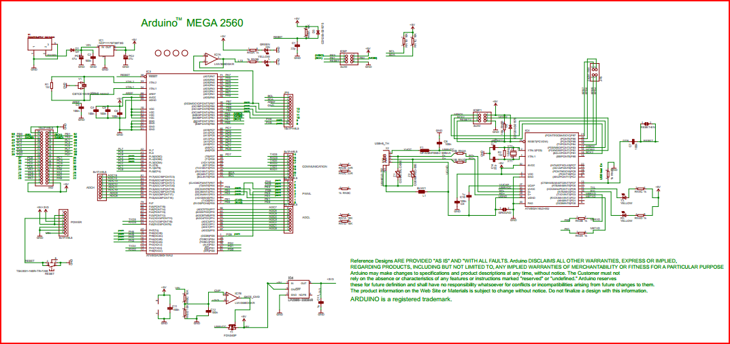

**Design Considerations**

**Feasibility Analysis**

**Potential Markets and Applications**

**Project Timeline**

**Appendix: System Requirements**